Policy Date: | September 2026 |  | Version: 1
Policy Review Date: | September 2028 |  | Headteacher:  Nitash Odedra | 
Ratified by Governing Body:
Chair of Governors: Sue Welford |  |  | 
Feedback and Marking Policy

Rationale
At Rushey Mead Primary School, we recognise the importance of feedback as part of the teaching and learning cycle and aim to maximise the effectiveness of its use in practice. We are mindful of also of the workload implications of written marking and of the research surrounding effective feedback.
Our policy is underpinned by the evidence of best practice from Education Endowment Foundation and other expert research. The Education Endowment Foundation research shows that effective feedback should:

- Redirect or refocus the learner’s actions to achieve a goal
- Be specific, accurate and clear
- Encourage and support further effort
- Be given sparingly whilst still being meaningful to move the children’s learning forward
- Provide guidance on how to improve and not just tell pupils when they are wrong

Notably, the Department for Education’s research into teacher workload has highlighted written marking as a key contributing factor to workload. As such, teaching staff at Rushey Mead have discussed alternatives to onerous written marking which can provide effective feedback in line with the EEF’s recommendations and DfE’s expectations, which emphasises that marking should be meaningful, manageable and motivating.

This policy has been co-designed with staff in September 2026 to ensure manageable workloads that directly serve pupil progress.

Key Principles
Our policy on feedback has at its core several principles:
- The sole focus of feedback and marking should be furthering children’s learning;
- Evidence of feedback and marking is incidental to the process; we do not provide additional evidence for external verification;
- Written comments should only be used where they are accessible to pupils according to age and ability;
- Feedback delivered closest to the point of learning is most effective and as such feedback delivered in lessons is more effective than comments provided later;
- Feedback is provided to both teachers and pupils as part of assessment processes in the classroom and takes many forms other than written comments; e.g.: verbal feedback, peer and self-assessment.
- Feedback is part of the school’s wider assessment processes which aim to provide an appropriate level of challenge to pupils in lessons, allowing them to make good progress.
- All pupils’ work should be acknowledged by teachers at the earliest appropriate opportunity so that it might impact future learning.
Within these principles, our aim is to make use of the good practice approaches outlined by the EEF toolkit to ensure that children are provided with timely and purposeful feedback that furthers their learning and that teachers are able to gather feedback and assessments that enable them to adjust their teaching both within and across a sequence of lessons.

Feedback and marking in practice

It is vital that teachers evaluate the work that children undertake in lessons and use the information obtained to allow them to adjust their teaching. Feedback occurs at one of three common stages in the learning process:
Immediate | Feedback during learning that enables teachers to respond to misconceptions straight away.
Summary | Feedback at key points in the lesson to evaluate understanding and identify next steps.
Review | Feedback after learning to inform future teaching and support pupil progress – may include written comments.

Feedback closest to the point of teaching and learning is likely to be most effective in driving further improvement and learning. As a school, we place considerable emphasis on the provision of immediate feedback. Where feedback is based on a review of work completed, the focus will often be on providing feedback for the teacher to further adapt teaching.

Learning Objectives
The Learning Objective will be flashed in green if the child has achieved it during the lesson.
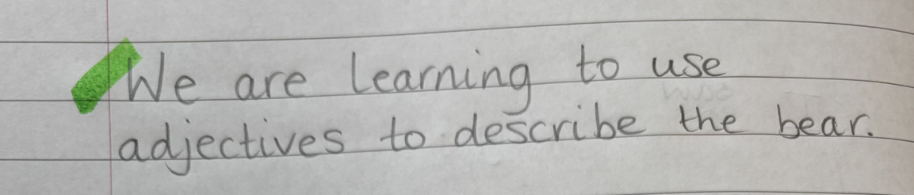
It will be indicated if a child has required support to achieve the Learning Objective. This may differ in the Specialist Base or Support Base where independence (I) might be the annotation.
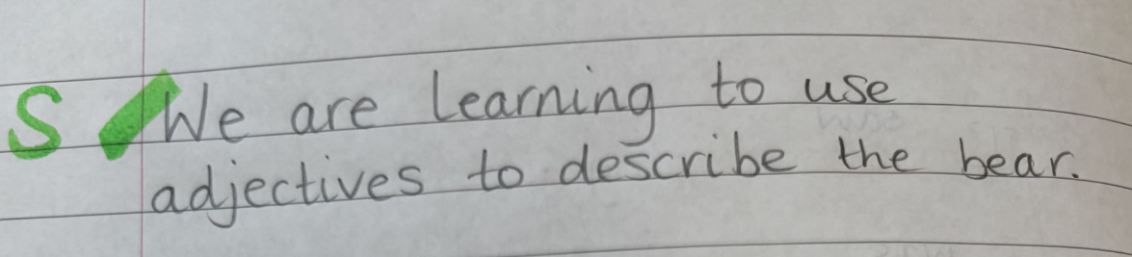
The Learning Objective will be flashed in orange if the child has not achieved it during the lesson.
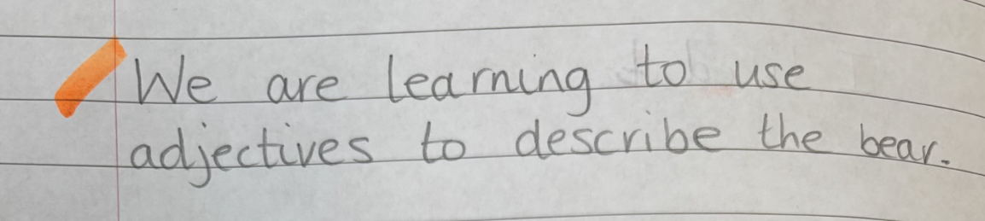

Colours and Coding
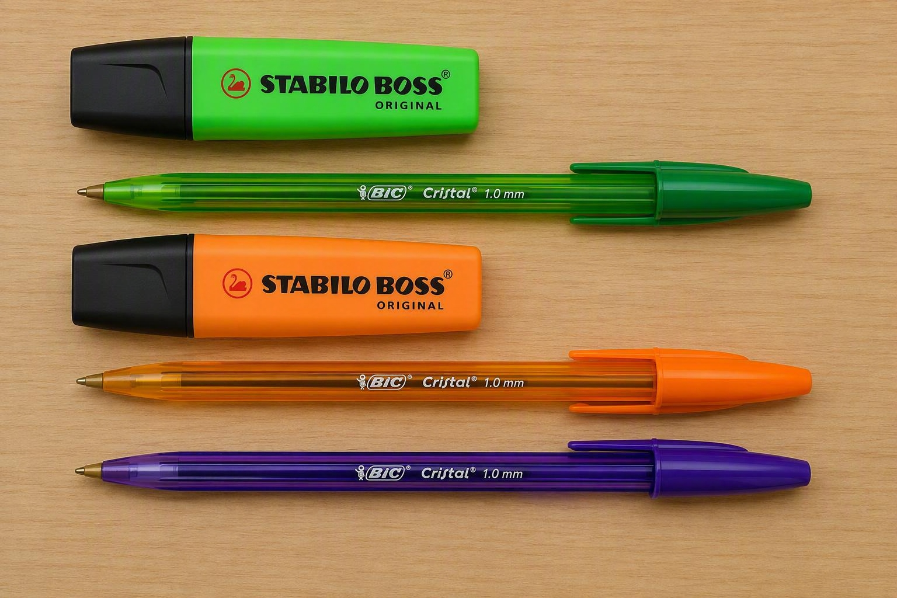
Whole school colours for marking:
- Highlighting or writing in green shows successes
- Highlighting or writing in orange shows where errors are located or offers meaningful written feedback.
- From Year 1 onwards, children use purple pens to correct those errors, practice a skill or respond to the feedback.

Light Marking vs Deep Marking

Light marking focuses on quickly identifying key errors, misconceptions or next steps without extensive written commentary. This may include highlighting spelling, grammar or punctuation errors, using agreed marking codes, ticking correct responses, identifying mistakes to revisit, or providing brief prompts such as "Add a fronted adverbial" or "Can you explain your reasoning?". The purpose of light marking is to provide timely feedback, promote pupil ownership of improvements and maintain a manageable workload for staff.

In contrast, deep marking involves a more detailed analysis of a pupil's work, including written explanations of misconceptions, specific next-step targets or an extended dialogue between teacher and pupil. As deep marking is significantly more time-consuming, it should be reserved for occasions where an extended piece of written work requires detailed feedback.

Non-negotiable expectations for written feedback
Written feedback should focus on the most significant errors or misconceptions that will have the greatest impact on future learning. Teachers will provide opportunity for pupils to act upon this feedback, correcting and improving their work so that misconceptions are addressed and not repeated. Pupil response is used to improve learning, address misconceptions and develop independence. It is not a means of generating evidence.

Where pupils demonstrate recurring errors, these must be explicitly identified and systematically addressed through targeted feedback and practice. Consistent pupil response to such feedback is expected using the purple pen in order to secure consistent high standards throughout the school. These expectations apply equally to spelling, grammar and punctuation and to the quality of handwriting, presentation and organisation of work.

Class or Key Stage Specific Guidance

Written guidance
Foundation Stage and Key Stage 1 | Marking will only lead to written comments for those pupils who are able to read the comments independently. Where pupils are unable to read or understand written comments, they are given verbal feedback at the next appropriate opportunity. Written evidence of verbal feedback is not required.
Key Stage 2 | Written marking and comments should be used where meaningful guidance can be offered and when it has not been possible to provide this during the classroom session. Where there is a common need, it may be appropriate for teachers to adjust planning or grouping children rather than providing a written comment.

Specialist Base / Support Base & High Needs SEND Children
Annotation | Meaning
Green | The date will be highlighted green if the child has successfully met the objectives in the lesson. A commentary of engagement in learning with comments shared on how the child has accessed or completed the task.
Orange | Work which needs further attention or displays an error, or misconception will be corrected with the pupil, in-the-moment in orange.  Where possible, pupils will be given the opportunity to practice a skill following an orange piece of feedback.  Where a pupil is unable to complete work due to regulation needs, a note will be made.
‘S’ or ‘I’ Symbol | Used to indicate whether work was Supported (S) or Independent (I).
 | A finger will be drawn below writing where finger spaces have been missed. Children will respond by rewriting the sentence, remembering their finger spaces.
Example | 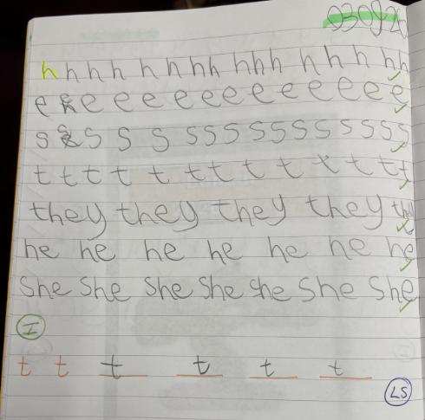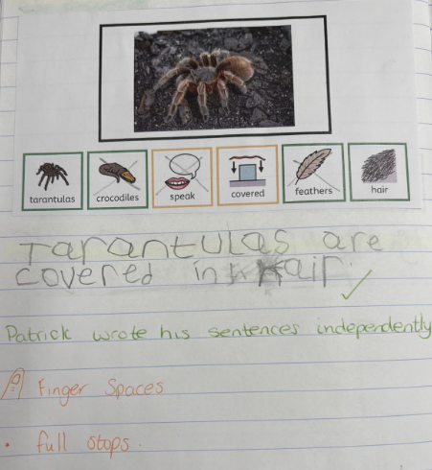  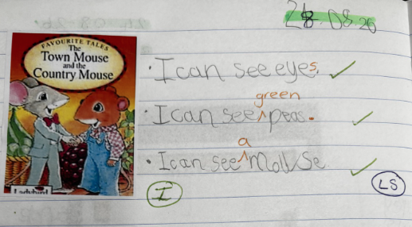

Nursery and EYFS
Annotation | Meaning
Green | Work which demonstrates that a pupil has met an element of the success criteria, demonstrated a particular skill or achieved the intended outcome.
Orange | Work which needs further attention or displays an error, or misconception will be underlined in orange highlighter  e.g. letter/number formation, letters needing capitalisation; errors in spelling, punctuation and grammar, poor word choice; organisation and presentation of written work, specific errors in calculation, etc.
Writing checklist | Teachers in Reception will use a variation of the following pictorial to support children with basic expectations and highlight in green or orange to indicate their achievements and targets moving forward.  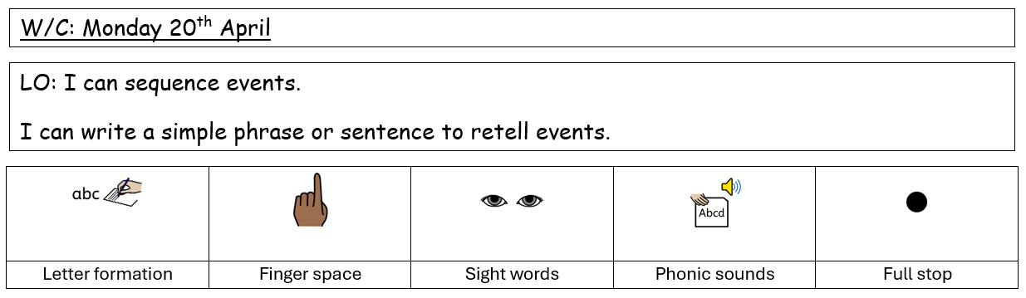
S | Children’s work will be annotated with a ‘S’ to indicate that work was supported by an adult.
Example | 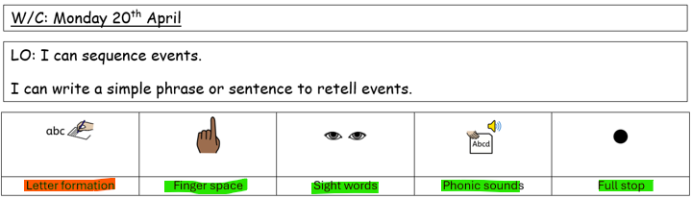  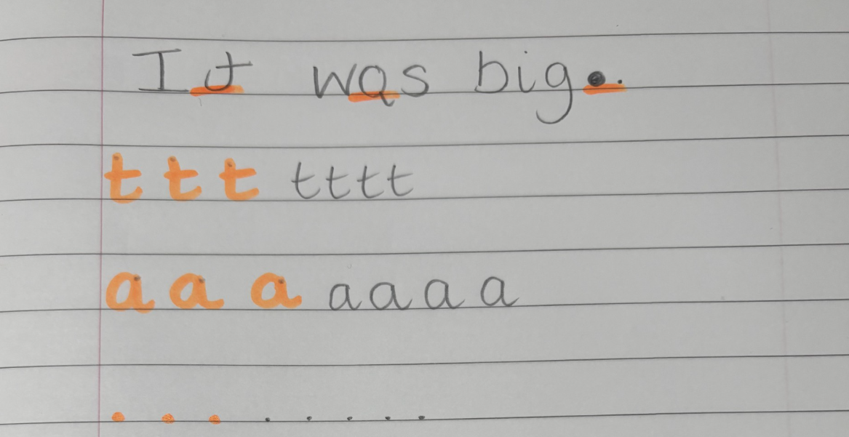

Key Stage 1
Annotation | Meaning
Green | Work which demonstrates that a pupil has met an element of the success criteria, demonstrated a particular skill or achieved the intended outcome.
Orange | Work which needs further attention or displays an error or misconception will be underlined in orange highlighter  e.g. letters needing capitalisation; errors in punctuation, errors in spelling and grammar, poor word choice; organisation and presentation of written work, high frequency words, letter/number formation, specific errors in calculation, etc.  Where children have missed out words an arrow symbol will be used in the gap to support the child inserting the missing word (∧).
 | A finger will be drawn below writing where finger spaces have been missed. Children will respond by rewriting the sentence, remembering their finger spaces.
Examples | 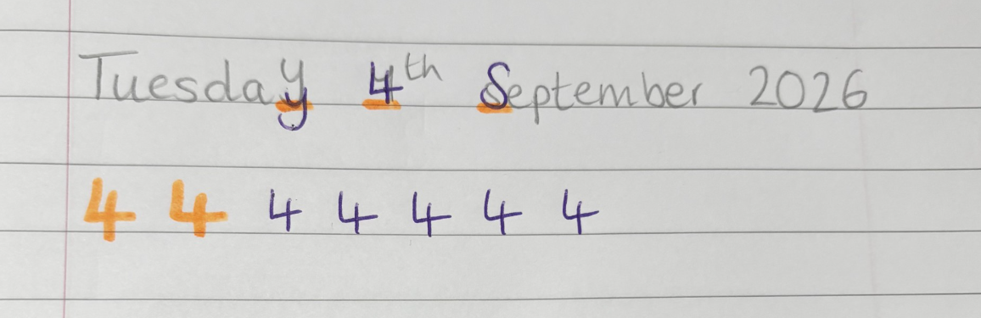  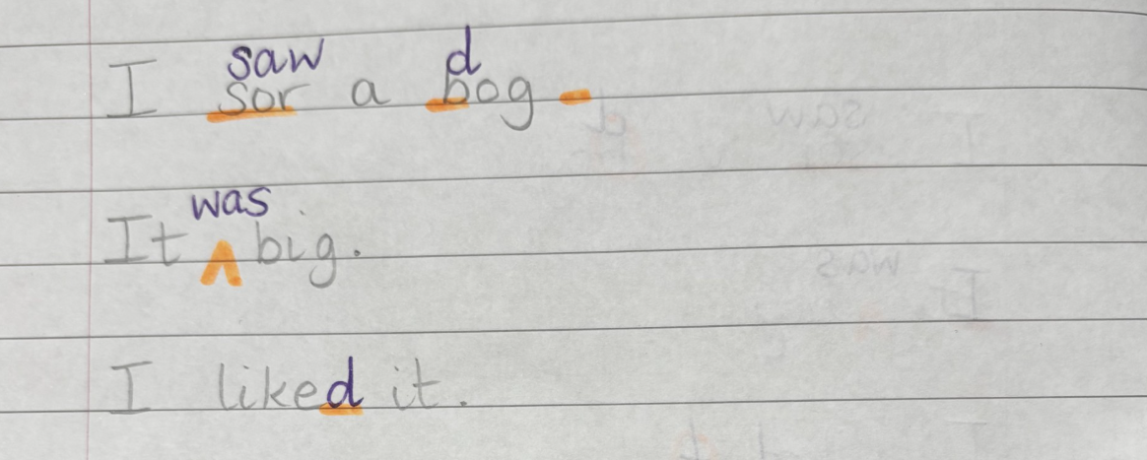

Lower Key Stage 2
Annotation | Meaning
Green | Work which demonstrates that a pupil has met an element of the success criteria, demonstrated a particular skill or achieved the intended outcome.
Orange | Work which needs further attention or displays an error or misconception will be underlined in orange highlighter.  Where pupils are showing higher levels of independence when proofreading and editing, a code will be written in the margin on the line of error in orange pen:  e.g. letters needing capitalisation; errors in punctuation (P), errors in spelling (teacher will underline in orange highlighter or write the word for the child to copy), errors in grammar (Gr), poor word choice; organisation and presentation of written work, letter formation, missing words (∧), specific errors in calculation, etc.
Example | 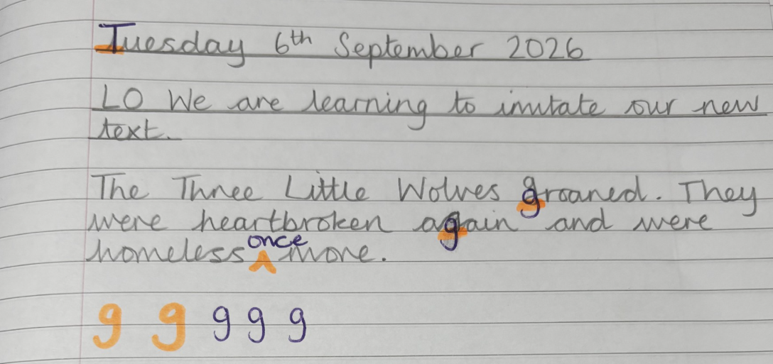  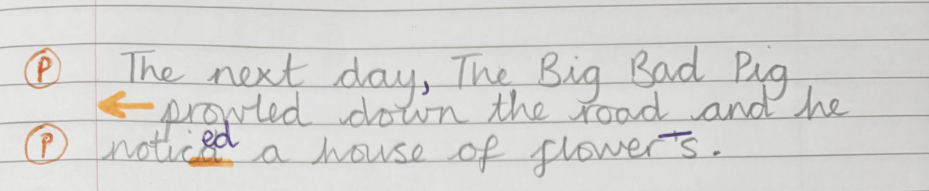  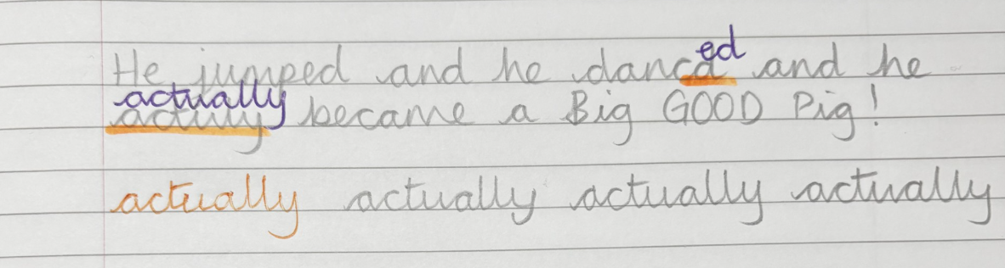

Upper Key Stage 2
Annotation | Meaning
Green | Work which demonstrates that a pupil has met an element of the success criteria, demonstrated a particular skill or achieved the intended outcome.
Orange | Work which needs further attention or displays an error or misconception will be underlined in orange highlighter or coded in the margin.  The aim is for children in Upper Key Stage 2 is to independently edit, improve and correct their written work to ensure their writing meets the outcomes relating to composition and the use of grammar (Gr), punctuation (P), spelling (Sp) and language rich vocabulary.  As children improve their independent editing abilities, particularly in Year 6, highlighting words will gradually reduce, leaving only codes in the margin, then these codes will be moved to the bottom of the piece of writing for children to locate independently.
Example | 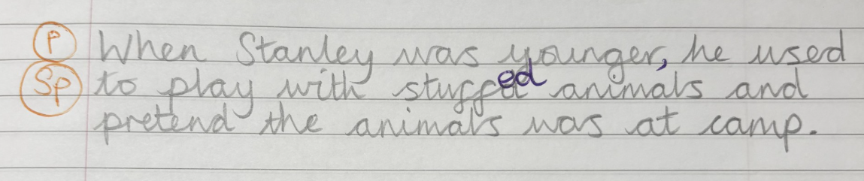  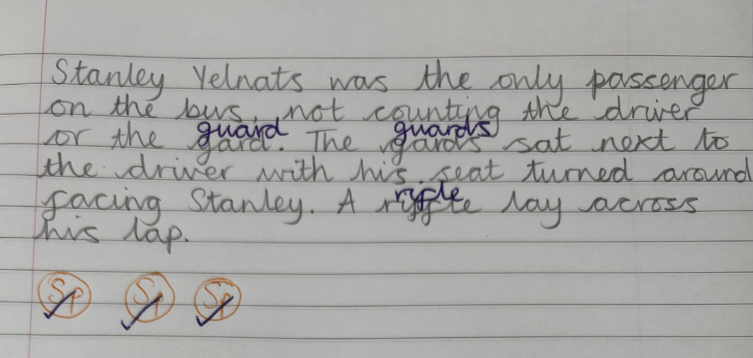  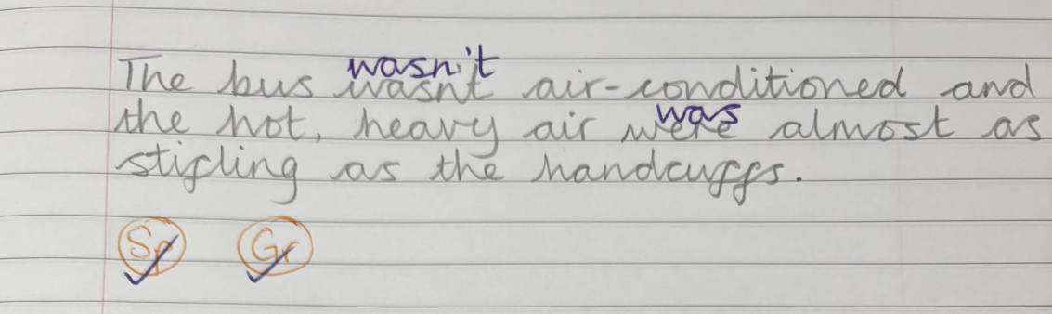

Adaptations
Where children are not working within the year group expectations for writing, the teacher will adapt their marking style to the appropriate stage of the child.
For example, a child in Year 5 who is not working at the expected National Curriculum level for writing, will have their feedback and marking pitched at the stage they are working within so that it meets their individual needs.

Foundation Subjects
Feedback and marking will be used to mark against the learning objective of the lesson. Wider writing will also be used as an opportunity to practice foundational writing skills such as letter/ number formation, spelling, handwriting, coherence and accurate grammar; the feedback and marking of foundation subject writing should be reflected as per the above colours and codes. A focus on core writing skills being used accurately remains important whenever children are producing pieces of writing.

