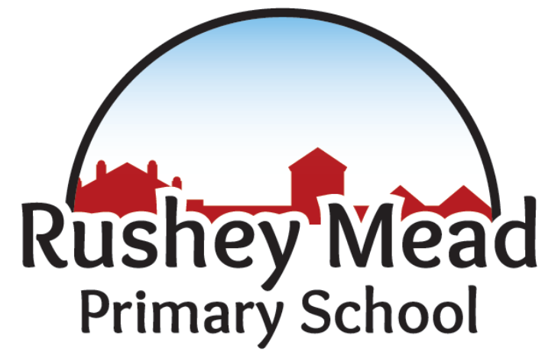

Single Equality Policy

Policy Date: | 20th November,  2023 |  | Version: 1.1
Policy Review Date: | November 2026 |  | Headteacher  Nitash Odedra | Signed  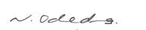 |  | Date  20/11/2023
Ratified by Governing Body:
Sue Welford  Chair of Governors |  |  | Signed   |  | Date: 20/11/2023

Equality and Diversity Statement
At Rushey Mead Primary School, we are committed to ensuring equality of education and opportunity for all pupils, staff, parents, carers, governors and all visitors to our school. We aim to develop a culture of inclusion and diversity in which all those connected to the school feel proud of their identity and able to participate fully in school life.
We will tackle discrimination by the positive promotion of equality, challenging bullying and stereotypes, and creating an environment which champions respect for all. At Rushey Mead Primary School, we believe that diversity is a strength, which should be respected and celebrated by all those who learn, teach and visit here.
Monitor and Review
Every three years, we will review our objectives in relation to any changes in our school profile. Our objectives will sit in our overall school improvement plan and, therefore, will be reviewed as part of this process.
Legal Duties
As a school, we welcome our duties under the Equality Act 2010. The general duties are to:
- eliminate discrimination
- advance equality of opportunity
- foster good relations
We understand the principle of the act and the work needed to ensure that those with protected characteristics are not discriminated against and are given equality of opportunity.
All groups below are covered within the Equality Act 2010 and some of the groups are also covered within the additional following named acts:
- Age (for employees only)
- Gender (including issues of transgender)
- Gender reassignment
- Maternity and pregnancy
- Religion and belief (includes lack of belief)
- Marriage and Civil Partnership (for employees)
Disability Equality Act (s005)
- Disability
Race Relations (Amendment) Act (2000)
- Race
Equality Act (Sexual Orientation) Regulations (2007)
- Sexual identity

In order to meet our general duties, listed above, the law requires us to do some specific duties to demonstrate how we meet the general duties. These are to:
- publish equality information – to demonstrate compliance with the general duty across its functions
We will not publish any information that can specifically identify any child or employee of the school
- prepare and publish equality objectives
To do this, we will collect data related to the protected characteristics above and analyse this data to determine our focus for our equality objectives. The data will be assessed across our core provisions as a school. This will include the following functions:
- Admissions
- Attendance
- Attainment
- Exclusions
- Prejudice-related incidents
Our objectives will detail how we will ensure quality is applied to the services listed above. However, where we find evidence that other functions have a significant impact on any particular group, we will include work in this area.
We acknowledge our responsibilities as an employer and will ensure compliance with the Equality Act 2010 in regard to the range of functions associated with being an employer.
We also welcome our duty under the Education and Inspections Act 2006 to promote community cohesion.
We recognise that these duties reflect international human rights standards as expressed in the UN Convention on the Rights of the Child, the UN Convention on the Rights of People with Disabilities and the Human Rights Act 1998.
In fulfilling our legal obligations, we will:
- recognise and respect diversity
- foster positive attitudes and relationships, and a shared sense of belonging
- observe good equalities practice, including staff recruitment, retention and development
- aim to reduce and remove existing inequalities and barriers
- consult and involve widely
- strive to ensure that society will benefit
Addressing Prejudice-Related Incidents
Rushey Mead Primary School is opposed to all forms of prejudice and we recognise that children and young people who experience any form of prejudice-related discrimination may fair less well in the education system. We provide both our pupils and staff with an awareness of the impact of prejudice in order to prevent any incidents. If incidents still occur, we address them immediately and report them to the Local Authority, using their guidance material. The Local Authority may provide some support.

Responsibility
We believe that promoting equality is the responsibility of Rushey Mead Primary School.
School Community | Responsibility
Governing Body | Involving and engaging the whole school community in identifying and understanding equality barriers, and in the setting of objectives to address these.
Headteacher | As above, including:  Promoting key messages to staff, parents and pupils about equality and what is expected of them, and can be expected from Rushey Mead Primary School, in carrying out its day-to-day duties.  Ensure that staff have the appropriate skills to deliver equality, including pupil awareness.  Ensure that all staff are aware of their responsibility to record and report prejudice-related incidents.
Senior Management Team/Senior Leadership Team | To support the Headteacher, as above.  Ensure fair treatment and access to services and opportunities.  Ensure that all staff are aware of their responsibility to record and report prejudice-related incidents.
Teaching Staff | Help in delivering the right outcomes for pupils.  Uphold the commitment made to pupils and parents/carers on how they can be expected to be treated.  Design and deliver an inclusive curriculum.  Ensure that you are aware of your responsibility to record and report prejudice-related incidents.
Parents | Take an active part in identifying barriers for the school community and informing the governing body of actions that can be taken to eradicate these.  Take an active role in supporting and challenging the school to achieve the commitment given to the school community in tackling inequality and achieving equality of opportunity for all.
Pupils | Supporting the school to achieve the commitment made to tackling inequality.  Upholding the commitment made by the Headteacher on how pupils and parents/carers, staff and the wider school community can expect to be treated.
Local Community Members | Take an active part in identifying barriers for the school community and in informing the governing body of actions that can be taken to eradicate these.  Take an active role in supporting and challenging Rushey Mead Primary School to achieve the commitment made to the school community in tackling inequality and achieving equality of opportunity for all.

Complaints
Complaints with regard to this policy will be dealt with via the Rushey Mead Primary School’s Complaints Procedure, a copy of which is available on the school’s website. A hard copy can be made available upon request.
Further guidance on the Equality Act 2010 can be found at: https://www.gov.uk/guidance/equality-act-2010-guidance

All of our school policies are interlinked and should be read and informed by all other policies.

