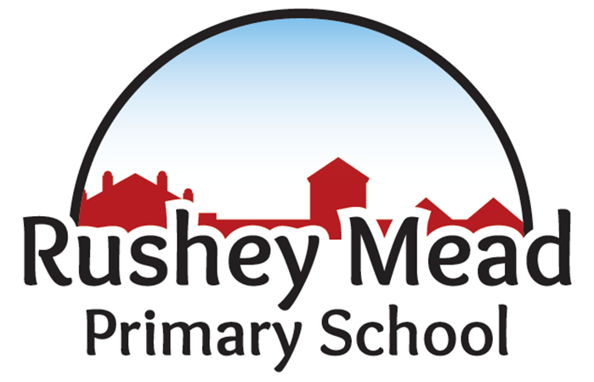
Broadening Horizons
Policy Date: | June 2024 |  | Version: 1.1
Policy Review Date: | June 2026 |  | Headteacher  Nitash Odedra | Signed |  | Insert Date
Ratified by Governing Body:
Sue Welford (Chair of Governors) |  |  | Insert Signature |  | Insert Date
Mathematics & Calculation Policy

Rushey Mead Primary School

Mathematics & Calculation Policy

Vision and Aims

‘Broadening Horizons’

At Rushey Mead Primary we have a shared vision for successful learning that effectively enthuses and engages all of our children. Working together as an effective team we foster a lifelong love of learning and an ambition to succeed.

Learning at Rushey Mead is an experience that:
Gives all children the opportunity to acquire the skills and knowledge needed to achieve academic success.
Puts an emphasis on the essential early acquisition of the English language.
Offers a challenging, engaging curriculum that develops children’s confidence and resilience.
Helps children to discover and extend their individual talents and strengths.
Celebrates the rich diversity of the local community and appreciates its enrichment of school life.
Prepares children for the future by promoting the importance of making a full, active and caring contribution to the lives of others

Intent

At Rushey Mead Primary School we aim to offer a broad-based curriculum to all pupils. This will support pupils in gaining a positive and confident attitude to mathematics: as a fascinating, practical and powerful subject. Children will be mathematically fluent, to master Maths, without resorting to rote learning. New mathematical concepts are introduced using a ‘Concrete, Pictorial and Abstract’ approach; enabling all children to experience hands-on learning when discovering new mathematical topics and allows them to have clear models and images to aid their understanding.
Our curriculum will encourage pupils to recognise the application of mathematics in a wide variety of everyday situations and develop their analytical skills whilst nurturing a spirit of enquiry.
We aim to develop oral and written communication skills within the subject that contribute to other areas of the curriculum where mathematics skills may be relevant.
Ongoing staff CPD ensures that teaching methods and resources will allow all children to have equal access to mathematics and to experience success and enjoyment in the subject in order to achieve their full mathematical potential.

Mathematic Implementation
Basic Maths lessons are taught daily and follow the National Curriculum Mathematics programmes of study which prioritises that children should:
- become fluent in the fundamentals of mathematics, including through varied and frequent practice with increasingly complex problems over time, so that pupils develop conceptual understanding and the ability to recall and apply knowledge rapidly and accurately;
- reason mathematically by following a line of enquiry, conjecturing relationships and generalisations, and developing an argument, justification or proof using mathematical language;
- can solve problems by applying their mathematics to a variety of routine and non-routine problems with increasing sophistication, including breaking down problems into a series of simpler steps and persevering in seeking solutions.

The school teaches the Primary Framework, using the Maths - No Problem! Themes are revisited at various intervals throughout Reception, Key Stages 1and 2, to ensure consolidation and progression outlined on the long-term plan. In all year groups teachers supplement these resources with appropriate materials from a range of sources.
The expectation is that the majority of pupils will move through the programmes of study at broadly the same pace in mixed ability whole class lessons. However, decisions about when to progress are based on the security of pupils’ understanding and their readiness to progress to the next stage. Pupils who grasp concepts rapidly are challenged through being offered rich and sophisticated problems. Those who are not sufficiently fluent with earlier materials will consolidate their understanding, including through additional practice in differentiated small groups, before moving on.

What Is Maths Mastery?
Teaching maths for mastery is a transformational approach to maths teaching which stems from high performing Asian nations such as Singapore. When taught to master maths, children develop their mathematical fluency without resorting to rote learning and are able to solve non-routine maths problems without having to memorise procedures.

A typical Maths lesson in Years 1 to 6 follows this structure:
- Retrieval Practice
- Explore is an anchor task based on a real-life problem which gives pupils the opportunity to interact with and learn from one another. Calculations/jottings are recorded in a Maths Journal
- Guided Practice lets the pupils solve problems using a number of different methods they may not have previously known which are recorded in a Maths Journal
- Independent Practice is the final part of the lesson where children complete the workbook individually.
- Challenge

Revise and Review consolidation lessons are used to revisit previous learning and ensure Maths skills are embedded.
Times Table Rock Stars (TTRS) is a maths programme used in KS2 that supplements the of learning times tables and has a proven track record of boosting children's fluency and recall in multiplication and division. Numbots is a maths programme used in KS1 to reinforce addition and subtraction. Certificates are awarded to celebrate improvements.

Cross-Curricular Links

In addition, children will have regular opportunities to develop and apply their mathematical skills in other areas of the curriculum. For example, measuring in science and design and technology, using properties of shape and patterns in art, and collecting and presenting data in history, geography and ICT.

Cross-curricular links are made in specific subject areas e.g.

- English – e.g. opportunities to write explanations in problem solving & note taking
- Computing – can be used for data handling and representation
- Science – use of data handling, measuring
- DT – measuring, scales
- Art – the properties of shape and patterns
- Geography- use of positional and directional vocabulary; collecting and presenting data

The Role of The Head teacher

In consultation with the Maths Leader, the Head teacher:

- determines the ways Mathematics should support, enrich and extend the curriculum;
- decides the provision and allocation of resources;
- decides ways in which developments can be assessed, and records maintained;
- ensures that Mathematics is used in a way to achieve the aims and objectives of the school;
- ensures that there is a Mathematics policy, and identifies a Mathematics leader.

The Role of the Maths Leader

The Mathematics Leader should:

- ensure the Primary Framework is followed for each child
- promote the integration of Mathematics within appropriate teaching and learning activities;
- manage the provision and deployment of resources and give guidance on classroom organisation and support for learning;
- lead INSET within the school, and investigate suitable courses elsewhere;
- act as a contact point between the school and support agencies, including the LA;
- provide technical expertise;
- analyse data to identify strengths and weaknesses in outcomes; planning for improvement accordingly.
- write, monitor and evaluate an action plan for Numeracy for the School Improvement Plan
- co-ordinate the evaluation and review of the school’s Mathematics policy.
- monitor & review the Mathematics provision within the school
- Ensure continuity and progression throughout the curriculum.


Calculation Policy


Early Years 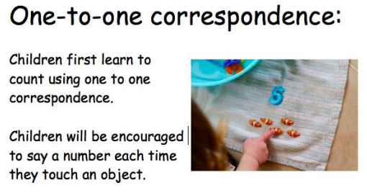
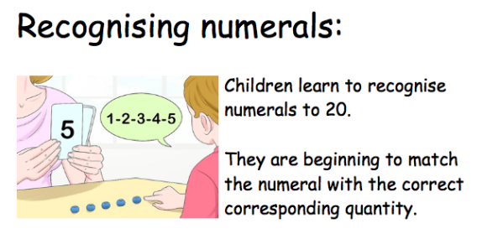
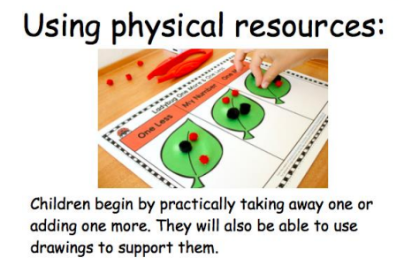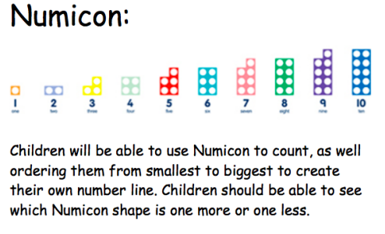
Early Years
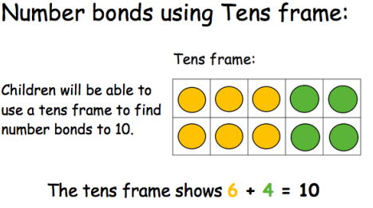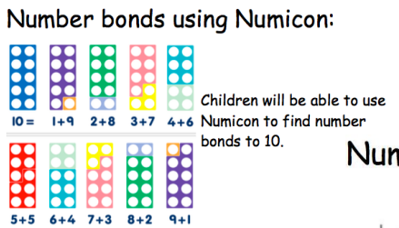

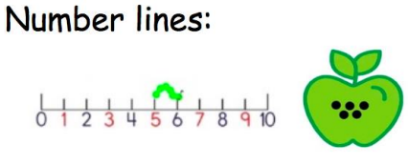 Children will be able to use a number line to count, as well as using it to take away or add one. This will be for numbers up to 20.

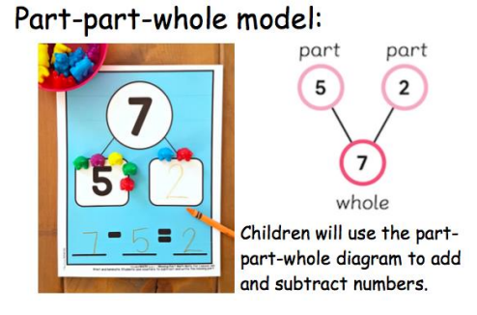

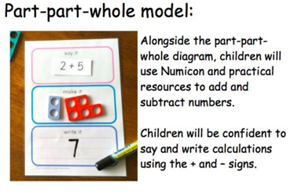
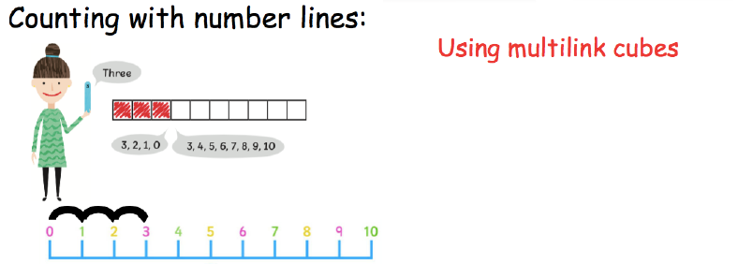
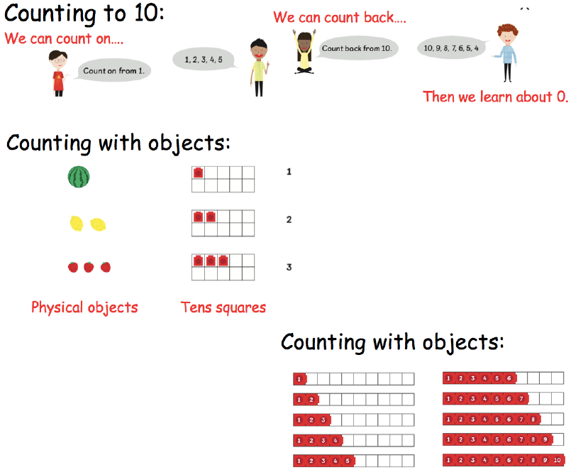
Year 1
Place Value- Counting
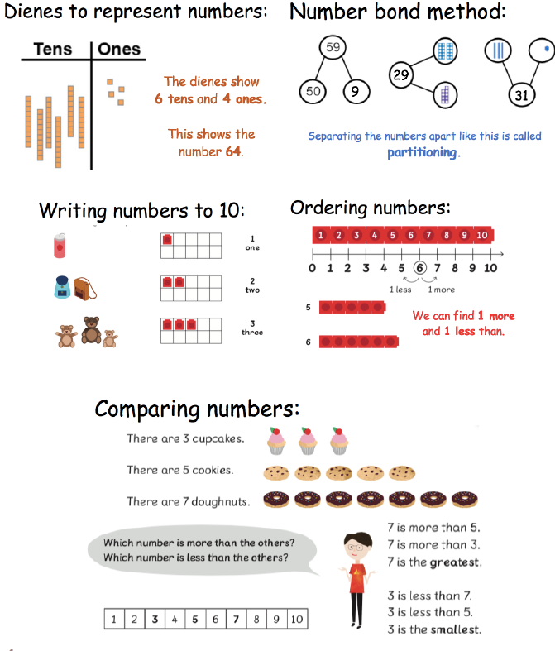
Year 1
Place Value
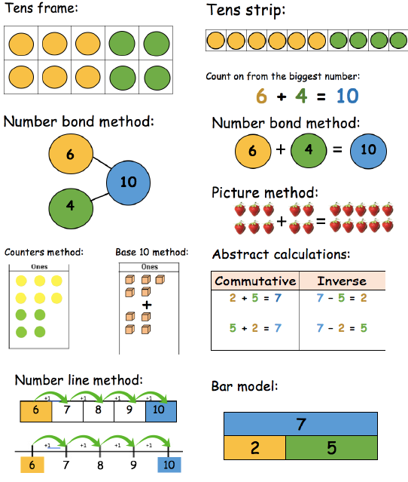
Year 1
Addition

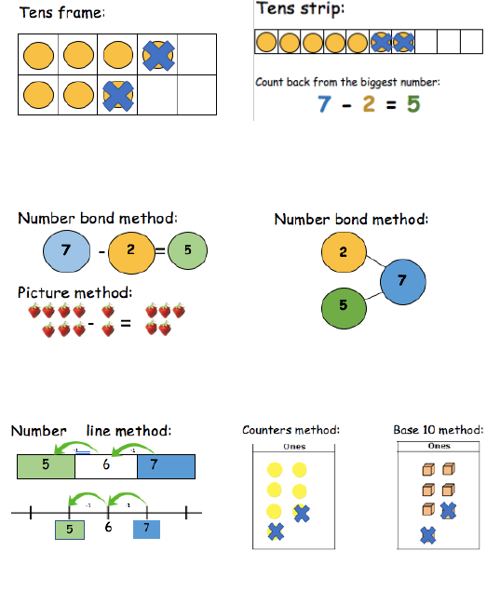
Year 1
Subtraction
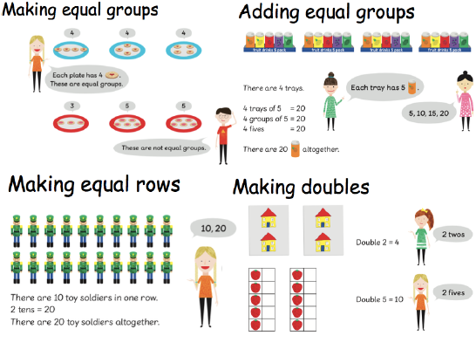
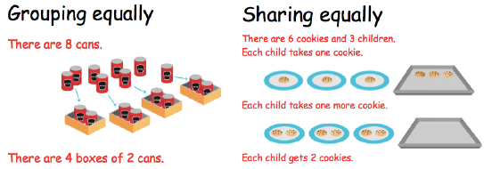
Year 1
Multiplication and Division
Year 2
Place Value
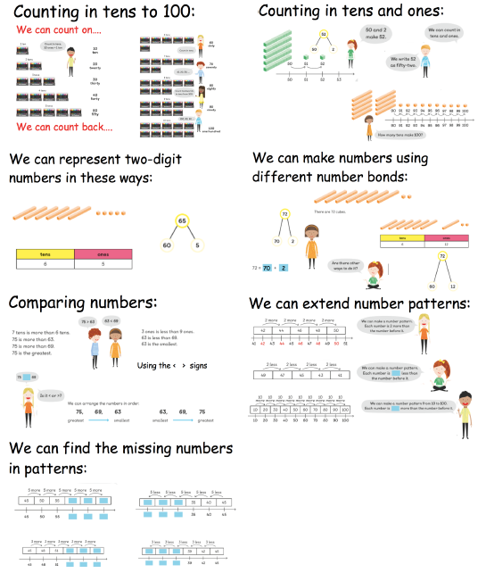
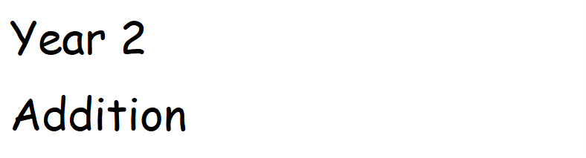

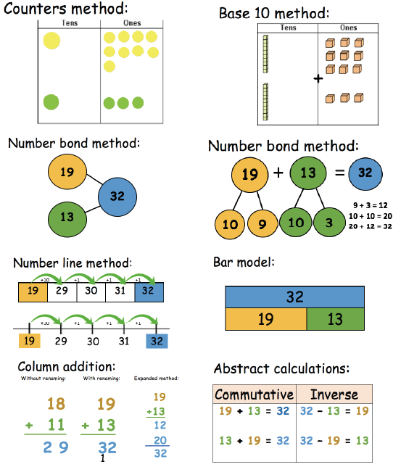
Year 2
Subtraction

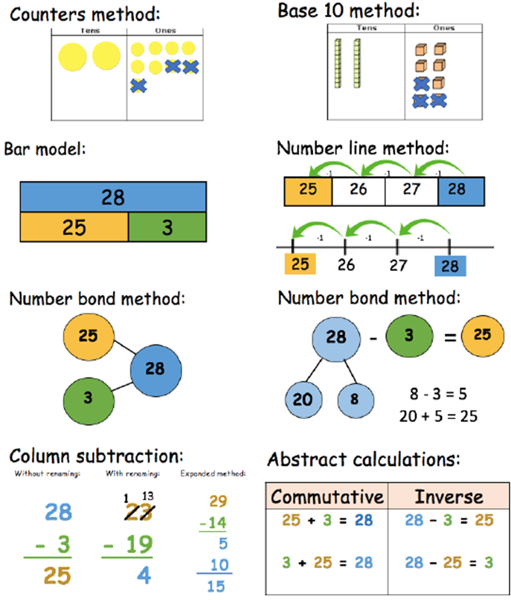

Year 2
Multiplication
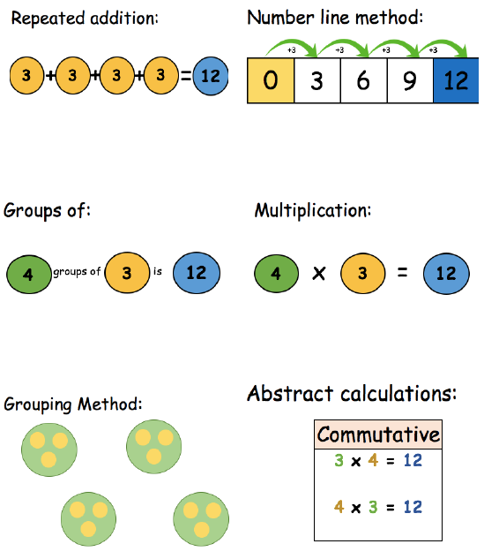

Year 2
Division

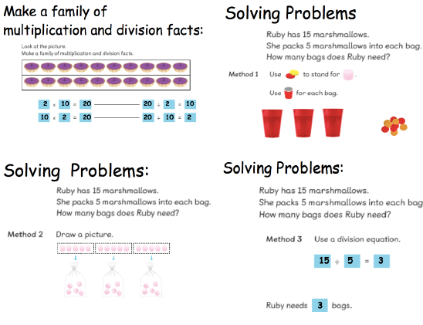

Year 3
Place Value

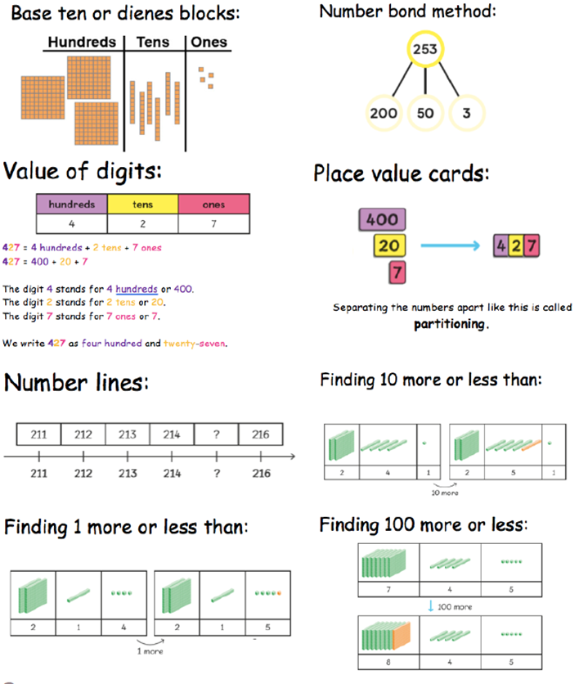
Year 3
Addition
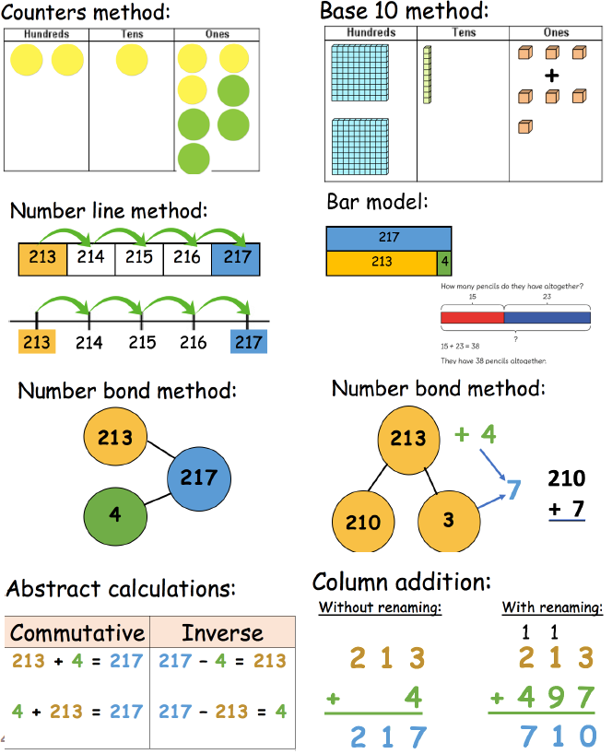
Year 3
Subtraction
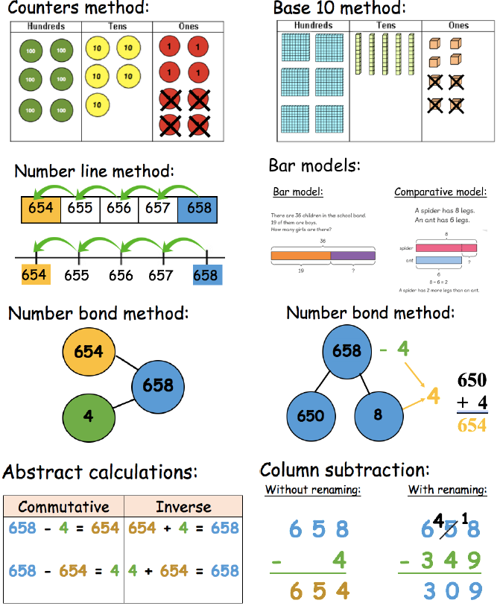
Year 3
Multiplication
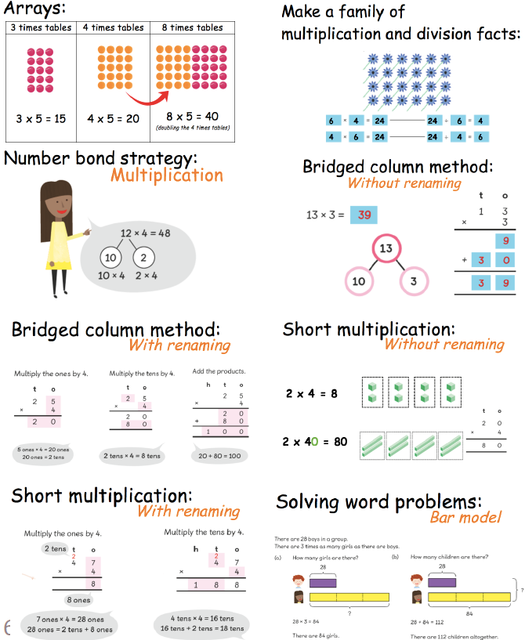
Year 3
Division
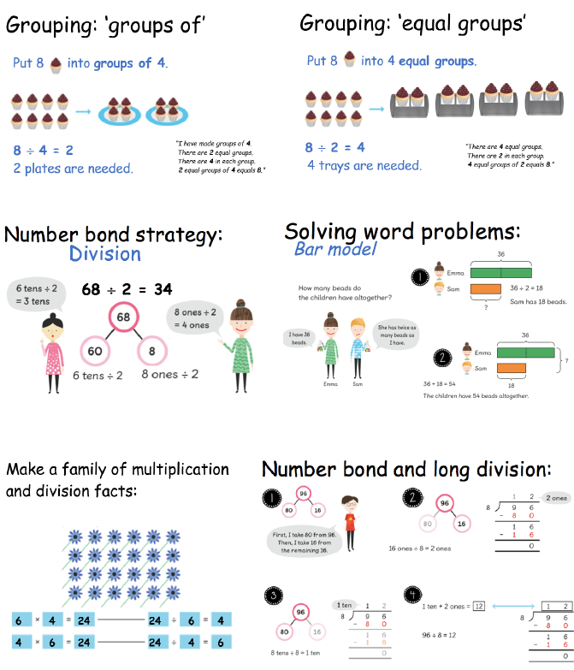
Year 4
Place Value
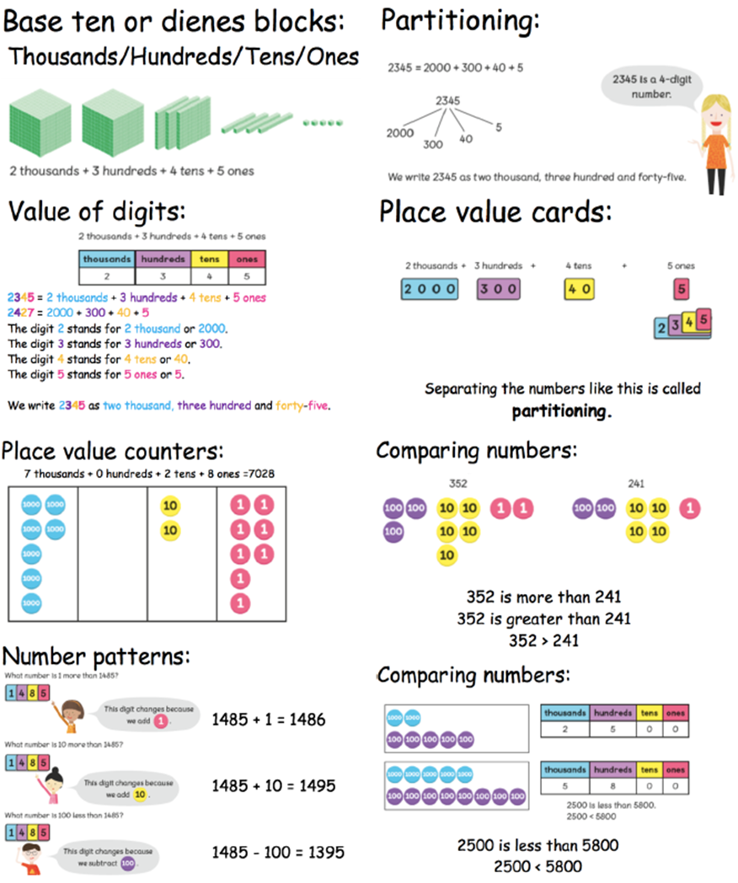

Year 4
Addition
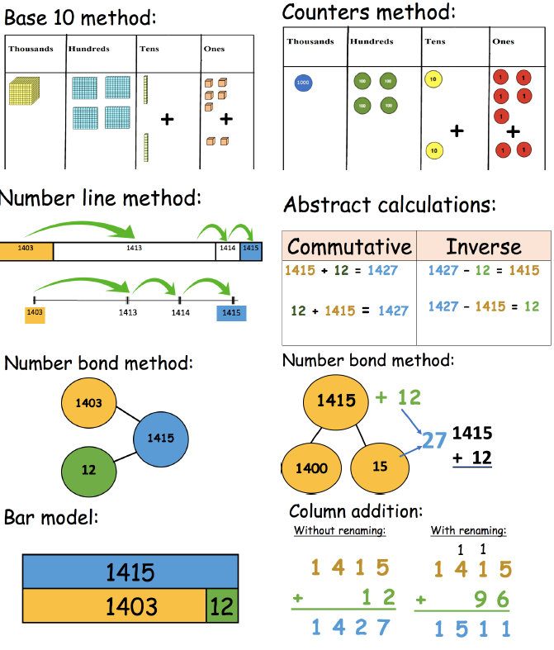

Year 4
Subtraction
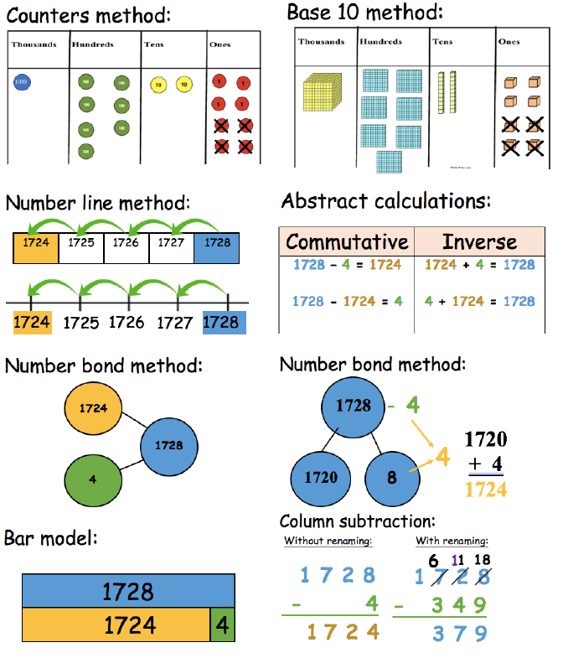

Year 4
Multiplication
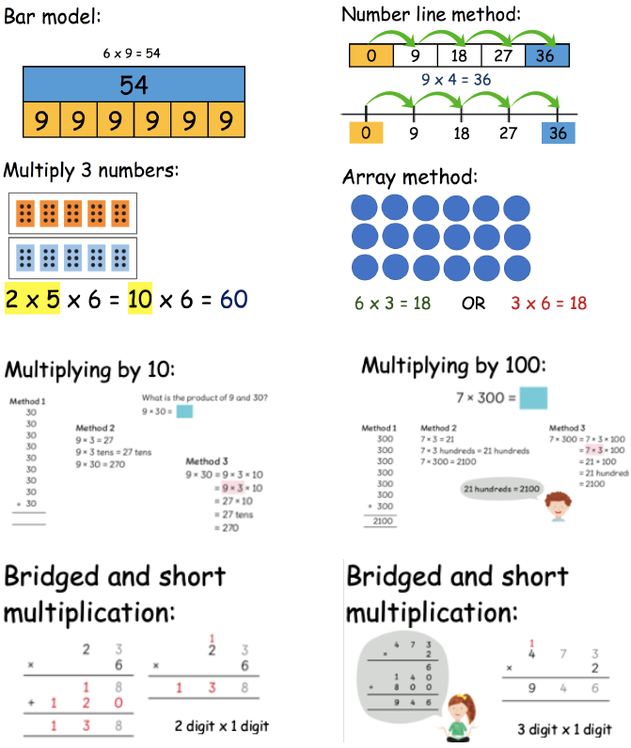
Year 4
Division
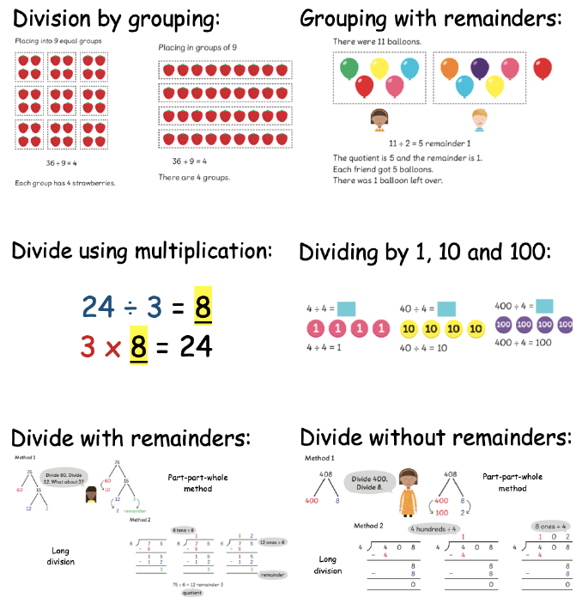

Year 5 and 6
Addition
Add numbers with more than 4 digits

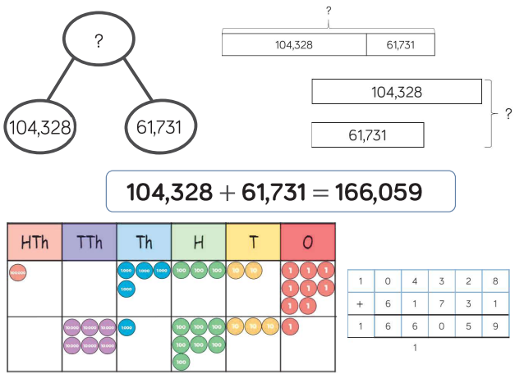
Year 5 and 6
Addition
Add with up to 3 decimal places
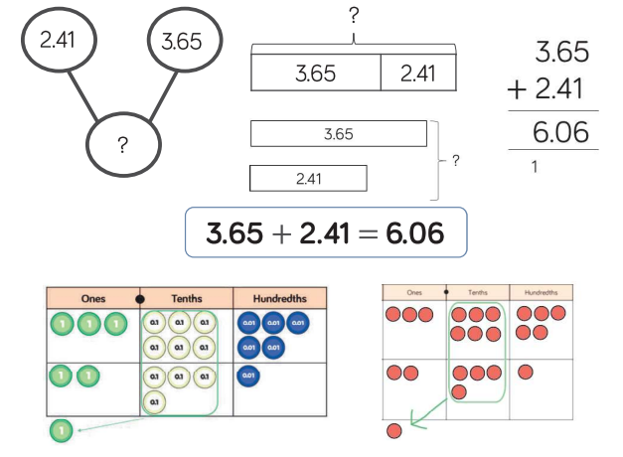

Year 5 and 6
Subtraction
Subtract numbers with more than 4 digits
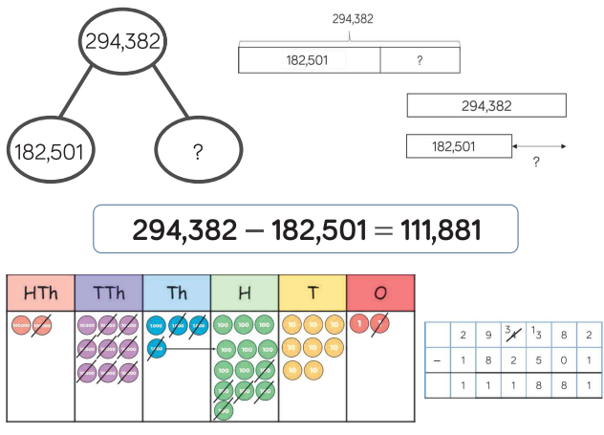

Year 5 and 6
Subtraction
Subtract with up to 3 decimal places
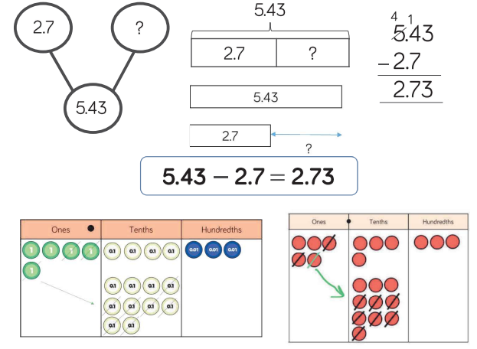

Year 5 and 6
Multiplication
Multiply 4-digit numbers by 1-digit numbers
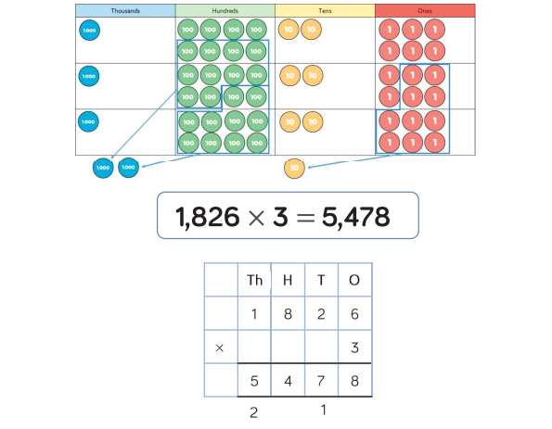

Year 5 and 6
Multiplication
Multiply 2-digit numbers by 2-digit numbers

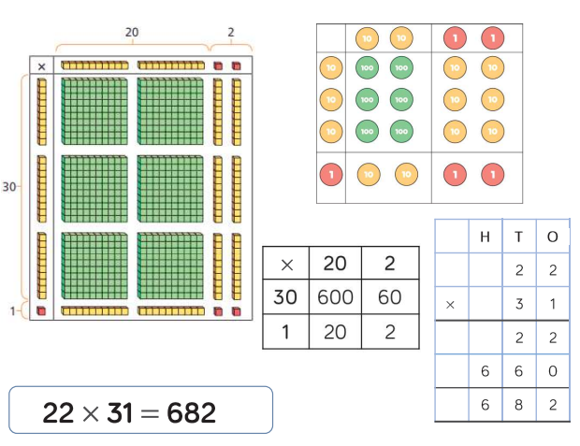

Year 5 and 6
Multiplication
Multiply 3-digit numbers by 2-digit numbers
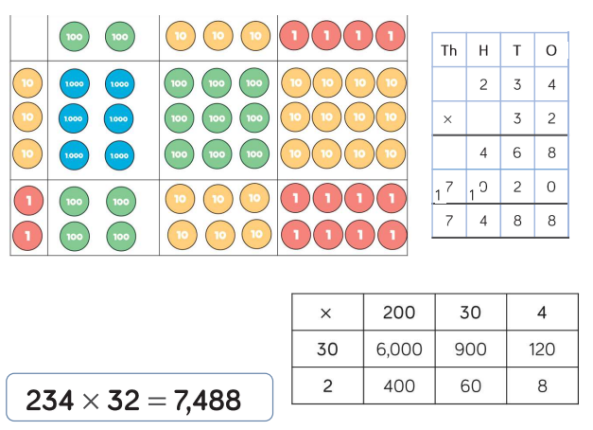

Year 5 and 6
Multiplication
Multiply 4-digit numbers by 2-digit numbers 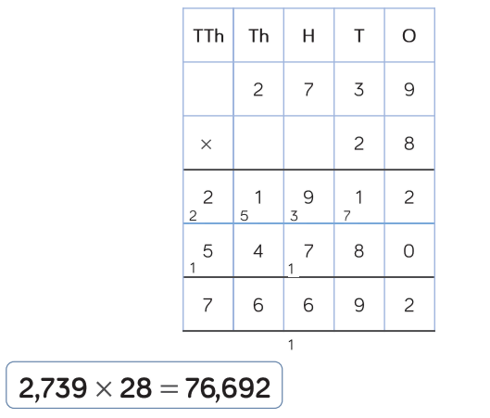

Year 5 and 6
Division
Divide 3-digit numbers by 1-digit numbers (grouping)
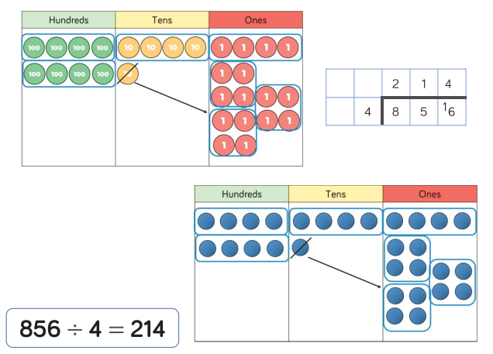

Year 5 and 6
Division
Divide 4-digit numbers by 1-digit numbers (grouping)
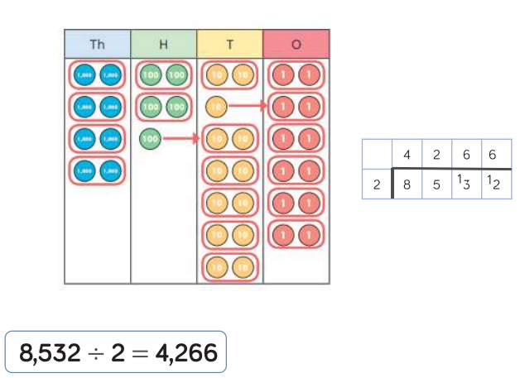

Year 5 and 6
Division
Divide multi-digit numbers by 2-digit numbers (short division)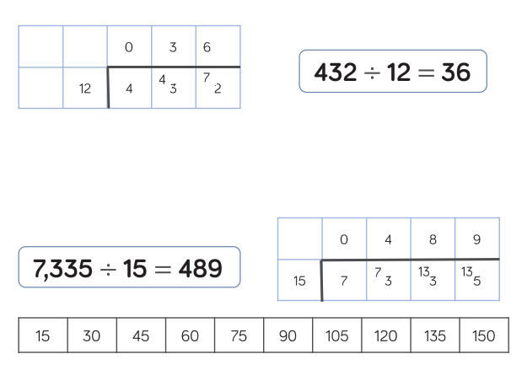

Year 5 and 6
Division
Divide multi-digit numbers by 2-digit numbers (long division)
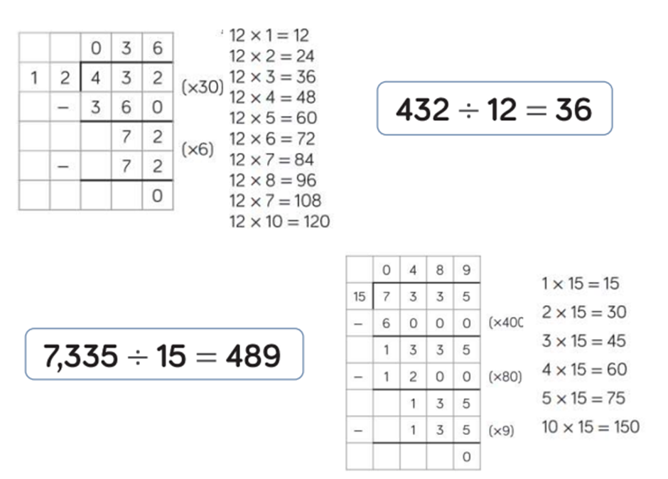
Year 5 and 6
Division
Divide multi-digit numbers by 2-digit numbers (long division)


