You will need:
Dried cous-cous
Vegetable stock (made up according to instructions)
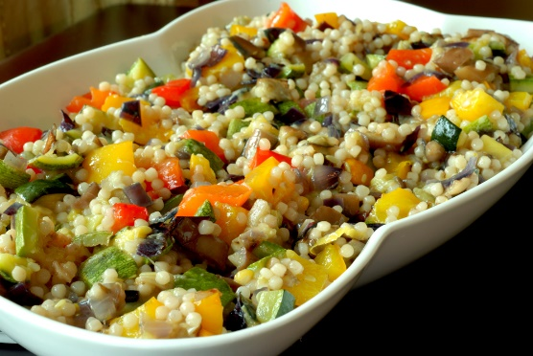
Yellow pepper
Cherry tomatoes
Sweetcorn
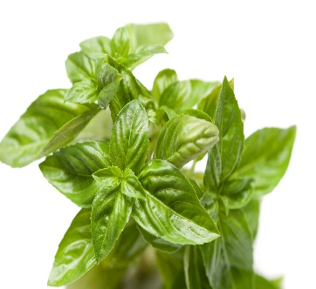
Fresh basil
This Photo by Unknown Author is licensed under CC BY
Olive oil
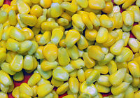
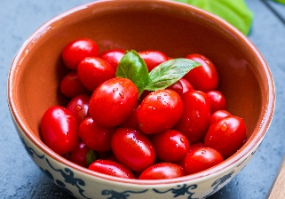

What to do:
- Measure dried cous-cous into a bowl
- Pour vegetable stock over the cous-cous
- Cover and leave for 7 min
- Meanwhile, chop the cucumber, pepper and tomatoes into small pieces
- Uncover the cous-cous and gently mix it using a fork
- Add all your vegetables to your cous-cous and gently mix through
- Drizzle with little olive oil
- Garnish with chopped basil


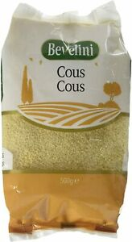
- Enjoy!

