Pizza muffins
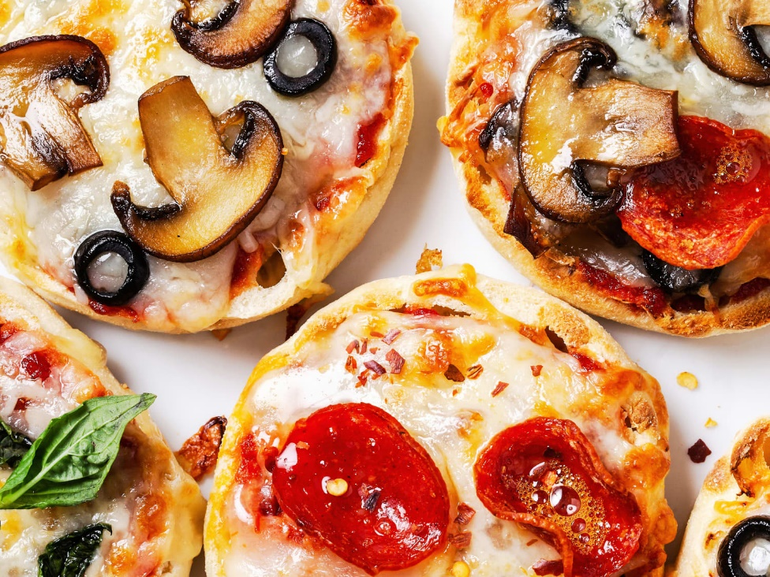

You need : Instructions:
Muffins
- Cut the muffin lengthways in half
- Preheat the grill
- Mix the tomato puree and garlic powder, season to taste
- Arrange the vegetables on your muffin
- Sprinkle the grated cheddar cheese on the top
- Put the muffins under the hot grill and watch so it doesn’t burn
- Enjoy!
Tomato puree
Mushrooms
Green olives
Peppers
Red onions
Cheddar cheese
Garlic powder
Mixed herbs

