Diwali chocolate treat
You will need:
2 plain digestive biscuits
Melted dark chocolate
Desiccated Coconut
How to make it:
- Crush the biscuits
- Mix the crushed biscuits into melted chocolate
- Shape your mixture into a small ball
- Roll the ball in desiccated coconut, covering all of its surface
- Place the finished sweet into a paper cup casing
- Enjoy!
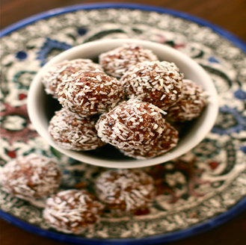
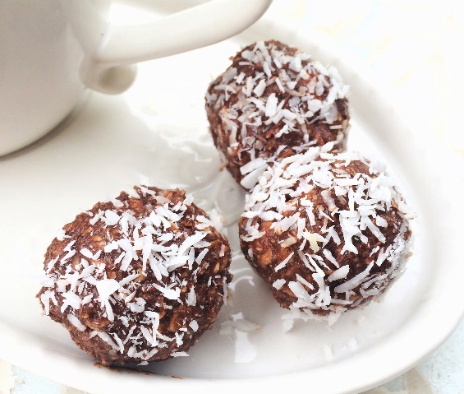
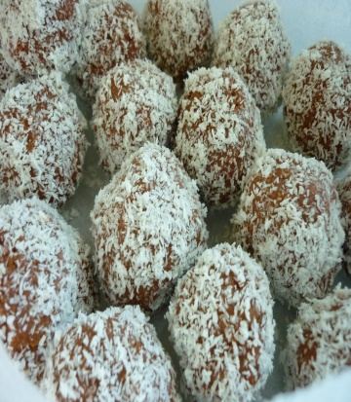
This Photo by Unknown Author is licensed under CC BY-NC-ND

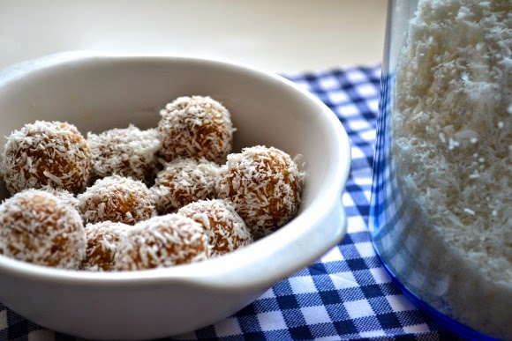
This Photo by Unknown Author is licensed under CC BY-NC

