Autumn Apple Doughnuts

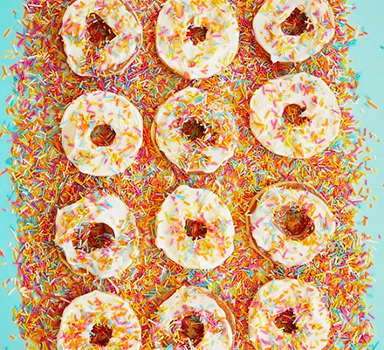
You need:
- soft cheese
- honey
- apples
- sprinkles to decorate

Instructions:
- Mix the soft cheese with the honey and set aside.
- Peel the apples,
- then slice each through the core into five or six rings, about 1cm thick.
- Use a small round biscuit cutter to stamp out a circle from the middle of each slice
- Pat the slices dry using kitchen paper – they should be as dry as possible to help the toppings stick
- Spread the soft cheese on the top of your slices
- Decorate with sprinkles

